OpenStreetMap Austria - Annual Report 2022/23

[Protocol of the annual meeting]
Report on the past year

Events
(summaries are linked at the end of the report)
- GI_Salzburg (05.07.2022)
There was an OSM lecture block and a booth.
- Grazer Linuxtage 2023 (14.04.2023 - 15.04.2023)
We had a stand there, which was well attended.

Other
- Local Chapter since 21.08.2022
- Radio interview „Null Island“ on the public Austrian radio station Ö1 (Matrix) (archived in the wiki)
- ESA workshop
- OSM business cards for distribution during faires and conferences
- OSM polos
- OSM mugs reorder
- OSM warning vests
- Registration for a background map with „registrations@openstreetmap.
→ an e-mail address has been created for APIs/websites where you have to register
- Request to BEV (governmental mapping agency): „Contradictory licence with OGD“.
→ We only got an unclear answer, it seems nobody wants to take responsibility.
- Collection of presentations (also: https://wiki.openstreetmap.org/wiki/OSM-AT/Praesentationen)
- Meeting with Katja from FOSSGIS regarding a possible conference in Vienna.

Q&A Questions
Via website Q&A some questions came in, which were answered by us:
- „How can I find a drinking water source“.
- „Who can give me a link for current OSM (Garmin) for Austria?“
- „Enter addresses in the building or attach them to the building via address flags?“
- „How can I display all house numbers in the WEB APP „Openstreetmap.org“?
- „I would like to visualise a travel route for a scientific essay.“
- „How can I find certain facilities or shops?“
- „How can I display an organisation on OpenStreetMaop?“
- „Offline maps“
- „Country download“

Info@ requests
Via info@openstreetmap.at we received some requests, which were (mostly) answered by us:
- „Would like to use the map under Garmin - Mapsource , is that possible ?“
- Josef Broukal with a question about trail mapping
(„Josef Broukal“ is a very well known moderator for the public television of Austria)
- „Support for SchülerLab“
- „Request for thesis topic“ → not answered
- „Change of address in Filzmoos“
- Again „Change of address in Filzmoos“ → this time not answered
- „OSM licences in school textbooks“
- „Joining process OSM Community Austria and motives“ → „I would be very happy if you could send me more information about the joining process and the motives of the current members.“
- „Do you have the domain sotm-eu.org?“
- „Openstreetmap Austria and WordPress“
- „Requesting support for EU-wide academic research study: bridging the AI gap in the EU!“ → not answered
- „Legal cycling routes in the Vienna Woods“
- „Request to add/ mend addresses“ (Forwarded from FOSSGIS).
- „Change“ (remove 2 routes) → were already removed
- (!) „State of the Map Europe - and other European projects“

New members
- ceyu
- Bernie38110
- Flo Ledermann
- mcliquid

Cash Report & Discharge of the Executive Board
Report on the calendar year 2022
We had more account transactions than in the previous year, a total plus of +774,47€ (income 989,96 - expenses 215,49).
Expenses: mainly internet server, account fees.
Income: Donations from exhibitions and stands (merchandise), membership fees, most donations (from „Climbing from Steyr to Weyer“ and members).
Cash balance at the end of the year: 3961,58€.
Calendar year 2023 (not formally part of this annual meeting, but an informal report was given)
Purchase of new merchandising material (mugs, safety waistcoats, polo shirts), resulting in higher expenses. Some of it has already been sold (without significant profit, as we are a non-profit organisation).
As our account details were on our homepage, someone set up a debit order to our account and debited over 1000€. Robert had the booking cancelled immediately. The account details were removed from our homepage.
Current account balance: about 2450€ (plus some merchandise of course).
Thanks to all donors!
Motion to discharge the board: unanimously accepted.

Trade fair material and merchandise of the association
New price card for merchandise.
- Warning Vests
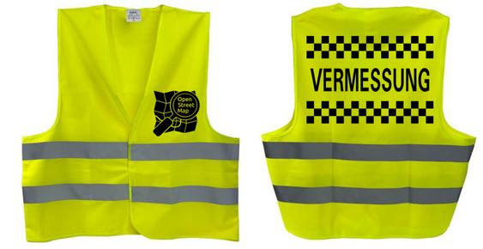
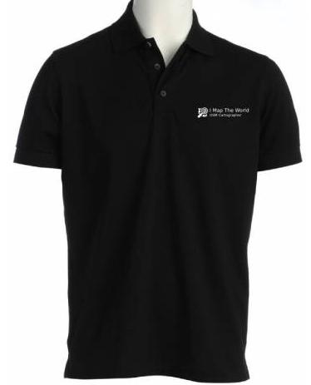
- Shirts

- Business Cards
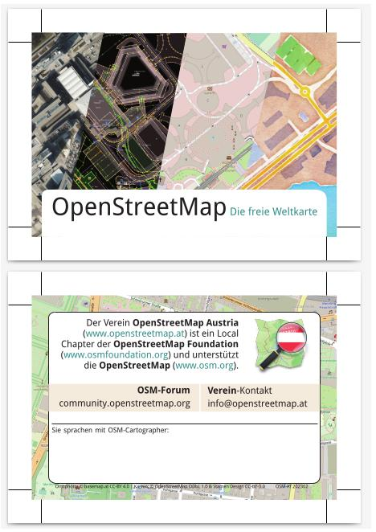
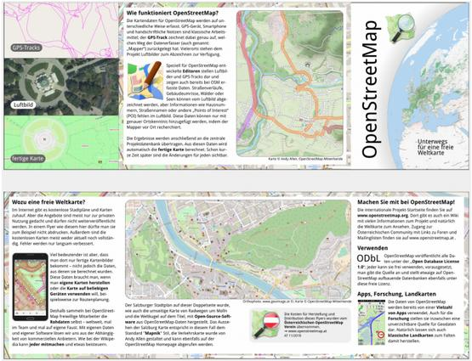
- Flyer

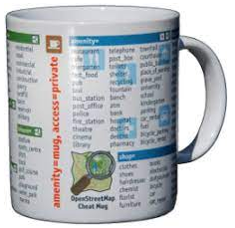
- Mugs

Future Participation in GI_Salzburg & other fairs
- Maker Faire Vienna (3-4 June 2023)
- GI Salzburg (July 2023)
- Linuxwochen Vienna (possibly in autumn 2023)

Hand cash
Motion by Robert Kaiser, moved at the beginning of the meeting and seconded by all present.
Motion: We leave the hand cash of 651,80€ to our former president for the consideration of storage and transport of association material. The materials remain in the possession of the association and he is requested to hand these things over to us.
Vote: unanimously accepted.
Markus informs the former president by registered letter.

Miscellaneous

FOSSGIS
Katja from the German FOSSGIS Association. Meeting with Robert Kaiser and Thomas (Snupo). Topics were:
There are considerations to hold one of their annual conferences in Vienna - possible venues, title of the conference, …
Travel expenses for GI Salzburg (stand „OSGeo/FOSSGIS/OSM“), which we submit to FOSSGIS every year (we are trying to simplify this)
Cooperation on merchandising

ViennaGeo Meetup
Possibly there should be ViennaGeo Meetups again. Since meetup.com is now fee-based, the registration could be taken over by the OSM-AT association. Then the OSM regulars' meetings could also be announced via the platform.

End of the general meeting
Markus ends the meeting at 20:34
Translated with www.DeepL.com/Translator (free version)

[Additions to the protocol of the annual meeting]

Report on the "Grazer Linuxtage":
This year we participated for the first time as Local Chapter OSM Austria at the Grazer Linuxtage (GLT). The Grazer Linuxtage took place from April 14th to April 15th. On the first day there were only workshops, where Stefan Tiran held a very well attended JOSM Workshop (https://pretalx.linuxtage.at/glt23/talk/JZSDTZ/).
On the second day there were several talks and information booths. OSM Austria presented itself at its information booth as usual. We were on site with 4 colleagues:
* Andreas Voit (geologist)
* Stephan Plepelits (skunk)
* Gerhard Rock (gerhard_rock)
* Stefan Tiran (StefanTiran)
The info booth was very well visited and we could answer many interesting questions. The spectrum of visitors ranged from „I have never heard of OpenStreetMap“ to students who had realized their own applications or projects with OpenStreetMap.
Next to the info booth geologist gave a talk „Mapping in OpenStreetMap for everyone or Gamification in OpenStreetMap“. This was also well attended (about 80 listeners) and can be viewed online thanks to the video recording - https://pretalx.linuxtage.at/glt23/talk/X7HTMX/ (only in German).
In summary, the Graz Linuxtage was a very interesting event for OpenStreetMap Austria and we are looking forward to GLT24.

Report on the GI_Salzburg 2022
Auto-Translation by Google-Translate: https://www-openstreetmap-at.translate.goog/2022/07/osm-at-auf-der-gi_salzburg_22/?_x_tr_sl=de&_x_tr_tl=en&_x_tr_hl=de&_x_tr_pto=wapp (Note by Dorothea Kazazi: Copy of the translated page below)

Report on the MakerFaire Vienna 2023
The Maker Faire Vienna 2023 happened just after the annual meeting, therefore it is included in this report.
Auto-Translation by Google-Translate: https://www-openstreetmap-at.translate.goog/2023/06/das-war-die-makerfaire-wien-2023/?_x_tr_sl=de&_x_tr_tl=en&_x_tr_hl=de&_x_tr_pto=wapp (Note by Dorothea Kazazi: Copy of the translated page below)
During the MakerFaire Vienna we were asked by the organizors of the MakerFaires of Hannover and Triest to also make an OpenStreetMap exhibition on their local faires in autumn. We directed them to the corresponding local chapters of Germany (FOSSGIS, www.openstreetmap.de) and Italy (www.osmit.it).

Report on the GI_Salzburg 2022

See next page

Automatic translation provided by OSM Austria – content copied on 2023-09-01 from
https://www-openstreetmap-at.translate.goog/2022/07/osm-at-auf-der-gi_salzburg_22/?_x_tr_sl=de&_x_tr_tl=en&_x_tr_hl=de&_x_tr_pto=wapp

OSM-AT at the GI_Salzburg_22
July 10, 2022 scubbx General , Fairs and Conferences , Salzburg 0
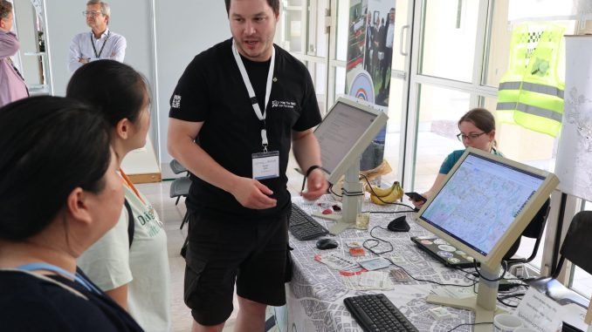
Visitors at the OSM stand at GISalzburg22
From July 6th to 7th, 2022, the successor to AGIT, the GI_Salzburg, took place in Salzburg. We, the OSM-AT association, were there and presented the OpenStreetMap project, the FOSSGIS association and OSGeo.

arrival and set-up
The journey began on Tuesday, July 6th, 2022. Since we do have some trade fair material and FOSSGIS eV had sent us banners, advertising material and stickers with FOSSGIS and OSGeo-specific material by post, Mapper geologist sacrificed himself as a driver and drove to Salzburg together with Mapper ScubbX.
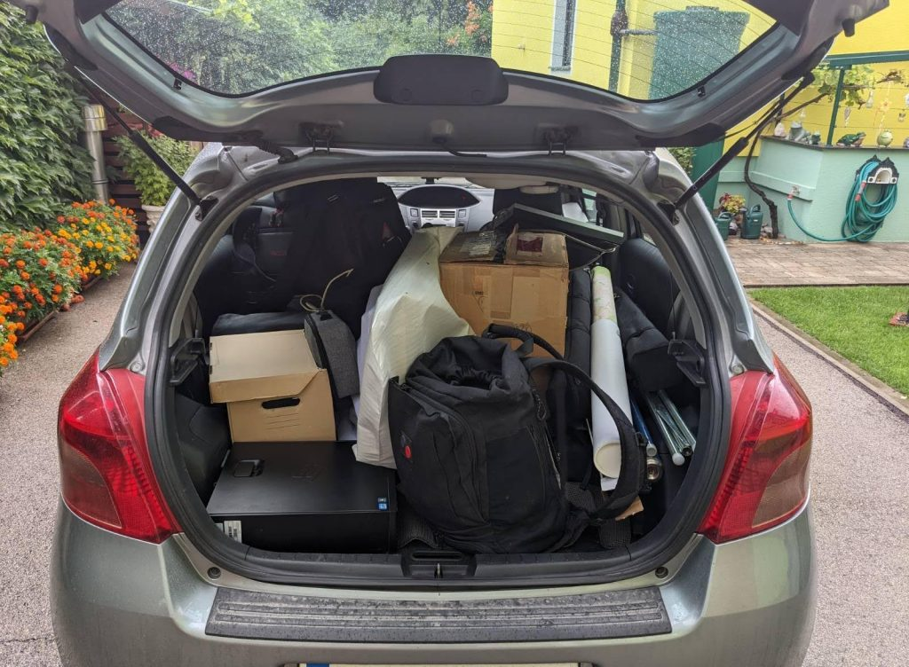
The not even fully packed car
Shortly after our arrival we were greeted on site by mappers bearT and negreheb, with whom we immediately started setting up the stand. We quickly came up with an optimal arrangement of the three tables provided by the organizers. We were even able to incorporate the pillar directly in front of the stand into the stand layout by rearranging it on three sides with OSM rollups and printed maps. After almost 3 hours we were done. Unfortunately, one of the laptops we brought along broke down immediately due to a defect, a sign for us to go through our trade fair material technically and update it if necessary (donations are welcome 😉 ). Nevertheless, we had 2 OSGeo-Live workstations with monitors,Show-Me-The-Way OSM visualization showed.
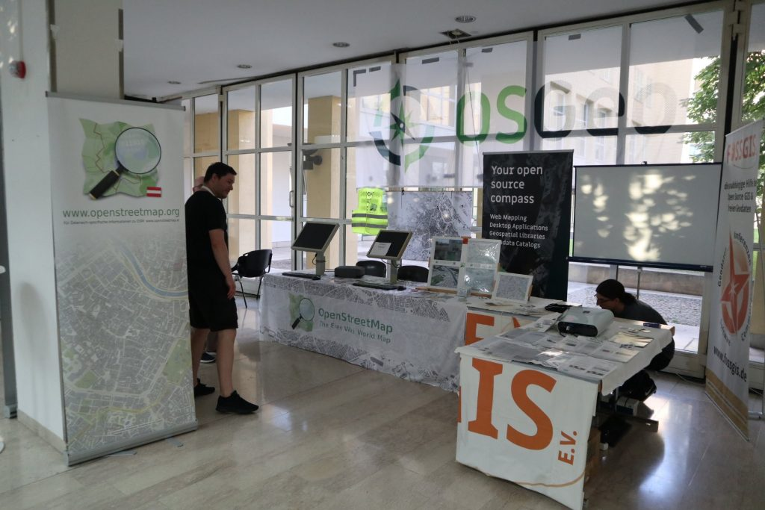

Our stand, almost completely set up
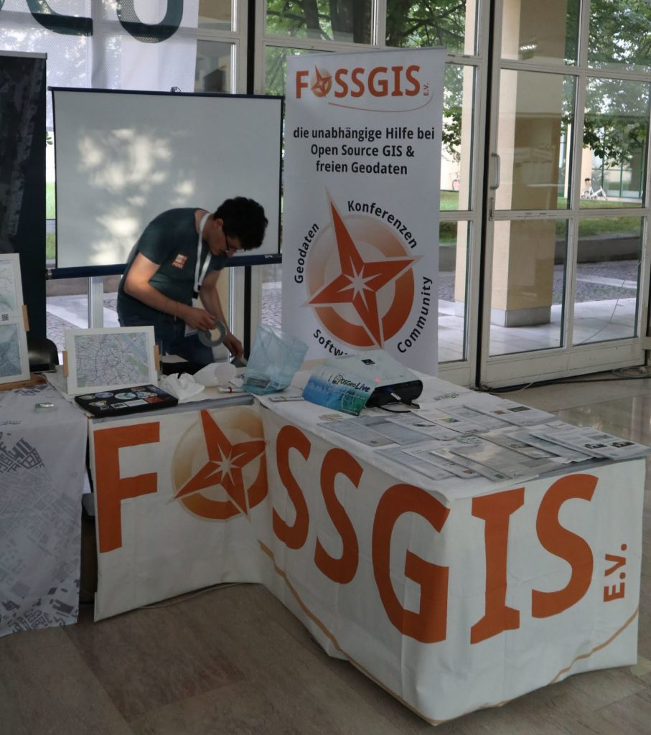
We pulled the FOSSGIS banner around 3 table edges

In the evening there was an ice breaker event where we were allowed to take part and where we got to know some of the trade fair and conference participants.

First day of the fair
Already on the first day of the fair there was a gratifyingly large influx of visitors. The workstations were always fully occupied. As of Wednesday, the former OSM-AT association member Jakob joined us as the fifth helper at the booth.
In the evening, the trade fair operations changed, because pre-ordered rolls and drinks were served at many stands. We had thought of something special for this: Homemade Earth Observation Cookies!
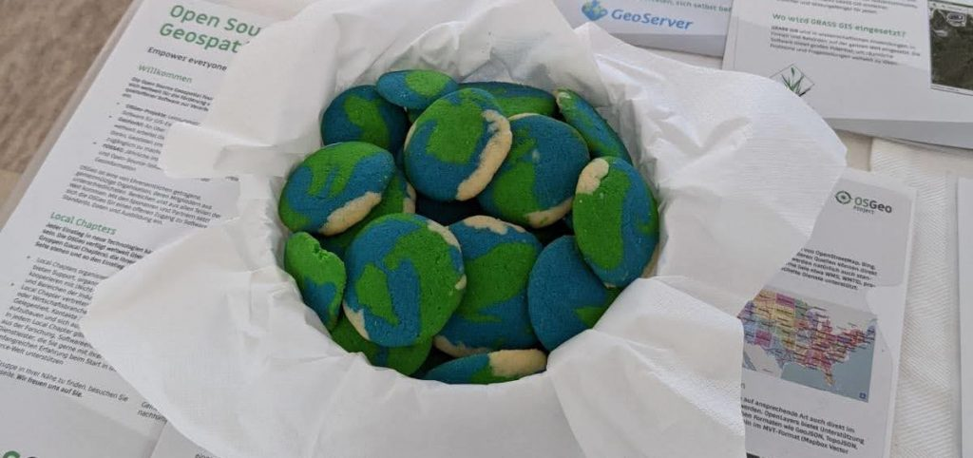
The Earth-Observation Cookies at our stand (only one of 3 baskets in the picture)
The Earth-Observation cookies were a big hit and while there were a few left, the amount was very small.

Second day of the fair
The second day of the fair got off to a somewhat slower start in terms of the number of visitors. This was not unpleasant for us, as it gave us the opportunity to finalize our 75-minute session.
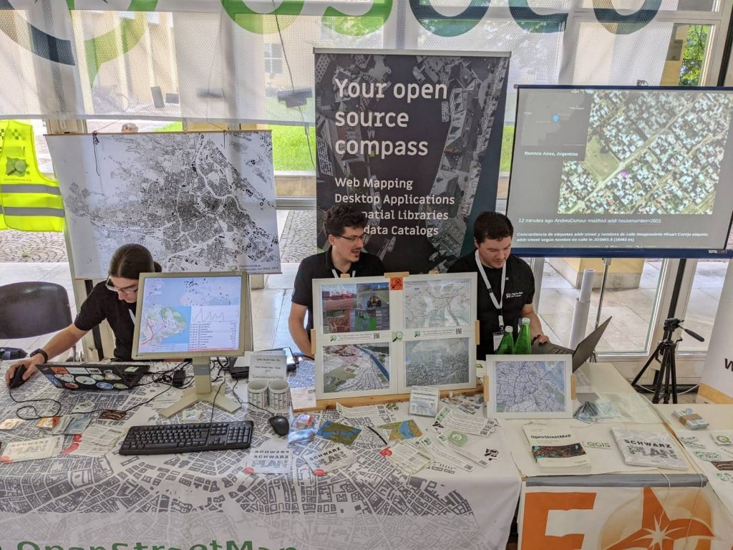
The preparation for our session is underway...
As content of this session we had planned a tour through the open source GIS landscape. Each of us 5 co-exhibitors had a 15-minute block to deal with one of the following main topics: OpenStreetMap, OGD data sources, GIS file formats, server applications, desktop GIS
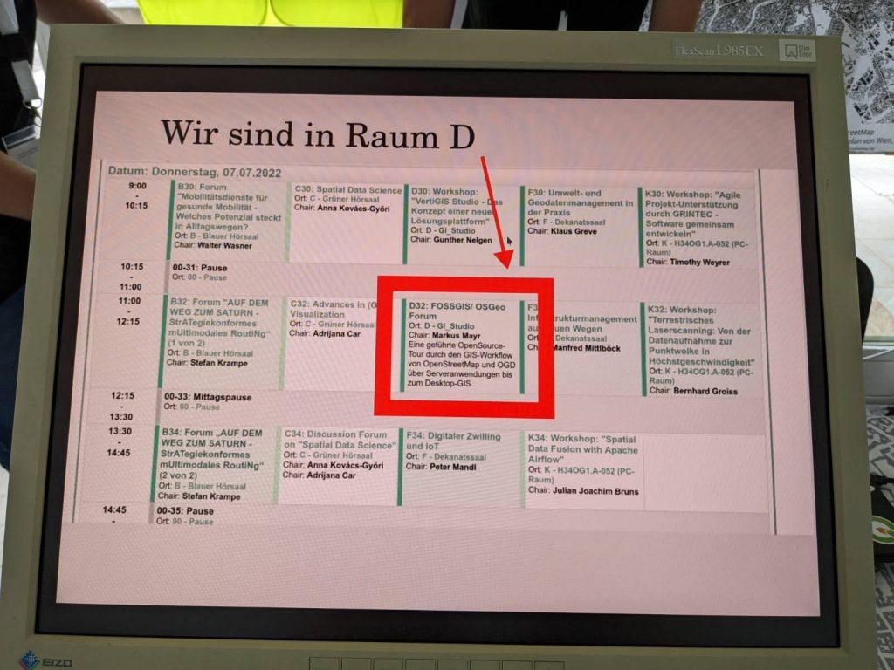
The message about our own lecture session
The lecture room immediately reminded me of a TedX stage as it was a fully equipped studio.
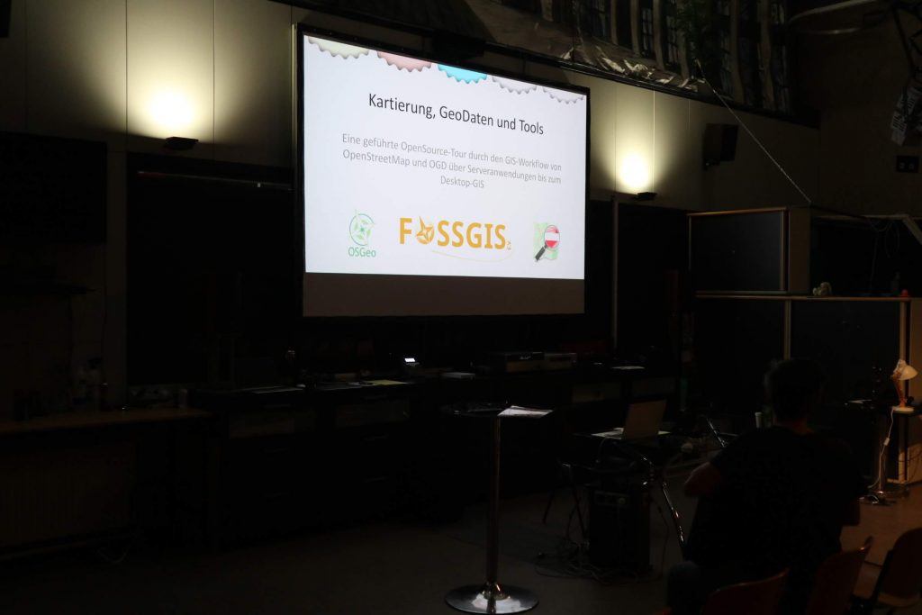
Our presentation is waiting to start
The lecture was well attended, an estimated 70% of the seats were occupied. As is usually the case with lectures, we ran out of time, we had much more to say than was possible. Nevertheless, we managed to only go over 3 minutes, unfortunately at the expense of a final round of questions and some interesting details that we couldn't show anymore. We pointed out that we can be contacted at any time at our stand. As a special extra, we recorded our presentation on camera. (As soon as this recording is finished, we will announce this in a separate post.) The slides of the lecture are already available at https://www.openstreetmap.at/2022/07/vortrag-der-gi_salzburg_22/ , the video can be found on youtube belowhttps://youtu.be/ZzwAXZqQL94 .
Of particular note is that we pointed out the incompatibility of the CC-BY 4.0 and the ODbL (see OSMF blog post ) , whereupon we were immediately approached by the OpenData managers of the City of Vienna, who were extremely interested in any problems between the two fix licenses.
After our session, the stand support continued, and a few people came who became aware of us because of our presentation.
The dismantling took place towards the end of the last lecture session of the conference. When we noticed that the other stands were starting to dismantle, we didn't hold back either and started cleaning up. With 5 booth supervisors, this was done extremely quickly and after about an hour you could no longer see anything of the sort where there were booths before.
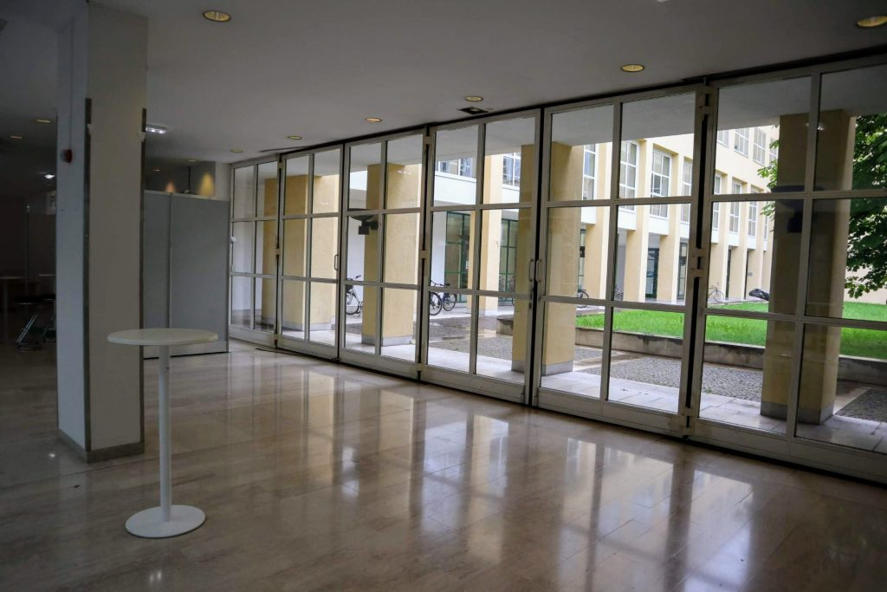
Our booth, dismantled again

final
It was a very exciting and exciting GI_Salzburg_22. We were very happy to be there. Purely felt, it felt good for the event to "only" run for two days - so the experiences remained crisp and interesting.
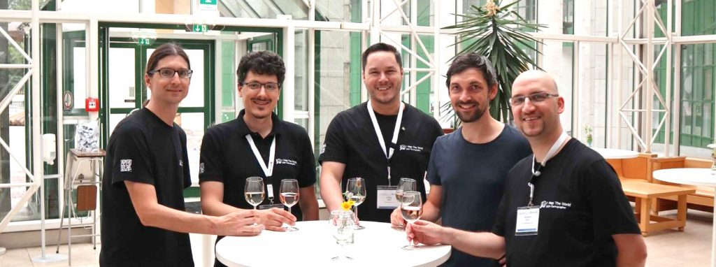
The OSM/FOSSGIS/OSGeo team of GI_Salzburg_22: bearT, ScubbX, negreheb, Jakob and geologist

Report on the Maker Fair Vienna 2023
See next page

Automatic translation provided by OSM Austria – content copied on 2023-09-01 from
https://www-openstreetmap-at.translate.goog/2023/06/das-war-die-makerfaire-wien-2023/?_x_tr_sl=de&_x_tr_tl=en&_x_tr_hl=de&_x_tr_pto=wapp

That was MakerFaire Vienna 2023
June 5, 2023 scubbx General , Fairs and Conferences , Vienna 1
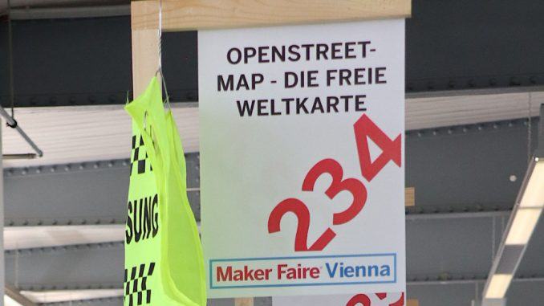
OSM stand lettering
On June 3rd and 4th, 2023, the Maker Faire, the trade fair for do-it-yourselfers and inventors, took place in the MetaCity in Vienna. We as the Austrian Local Chapter were also there!
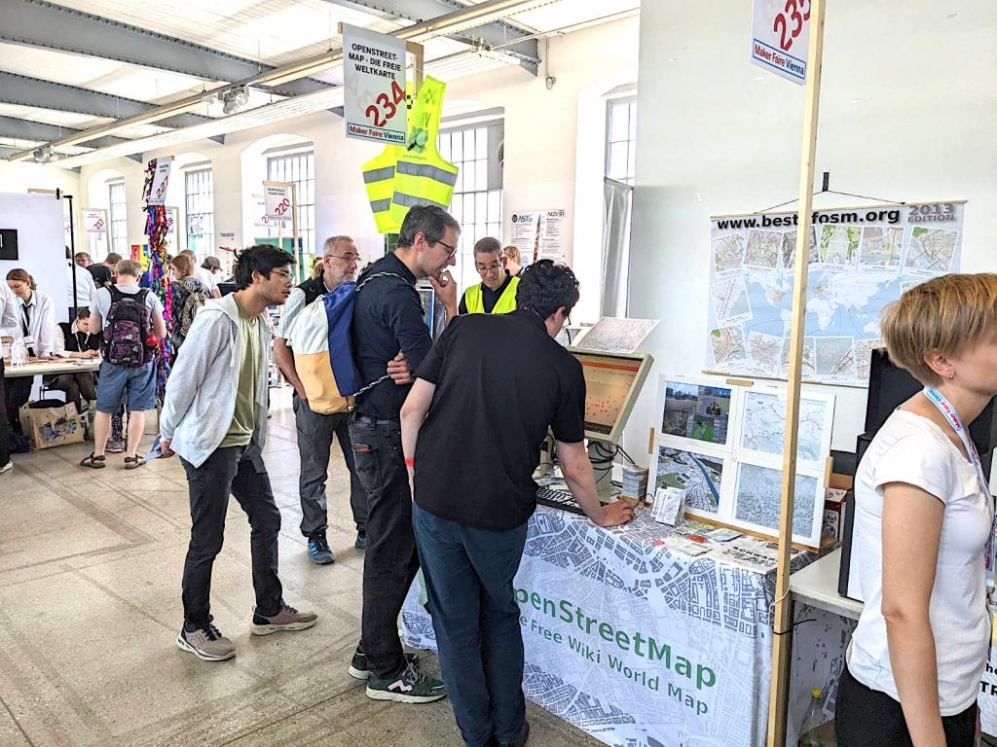
The OpenStreetMap (Austria) stand at the Maker Faire Vienna 2023
We had a great stand on the upper floor, which was positioned in a corner, which enabled us to set up a monitor on two sides of the table at the same time, on which we could introduce interested visitors to the world of OpenStreetMap - and there were quite a few of them on these two days! The three of geologist, ScubbX and Skunk occupied the OSM info table and hardly got any rest.
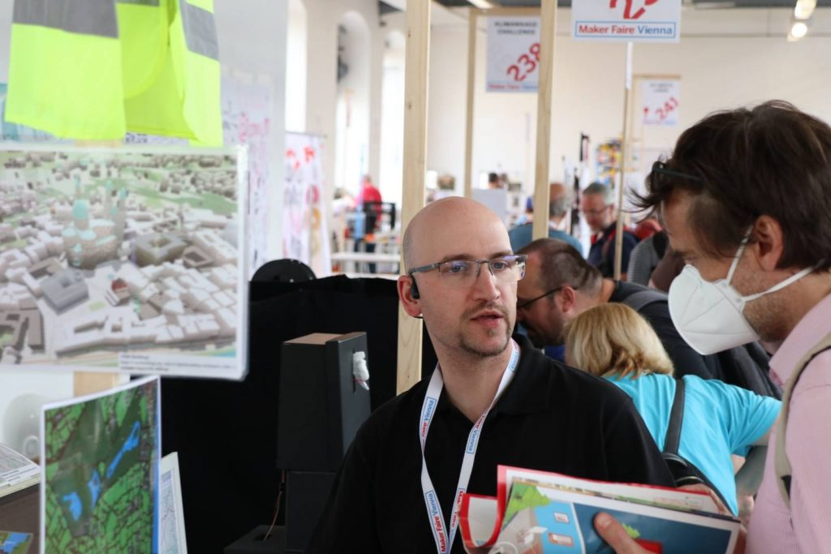
Mapper "geologist" explaining OpenStreetMap - in the foreground some of our laminated display boards with different rendering styles of OpenStreetMap
There was a wide range of different questions, there were visitors who had never heard of OpenStreetMap and those who told us about their own experiences with OpenStreetMap.
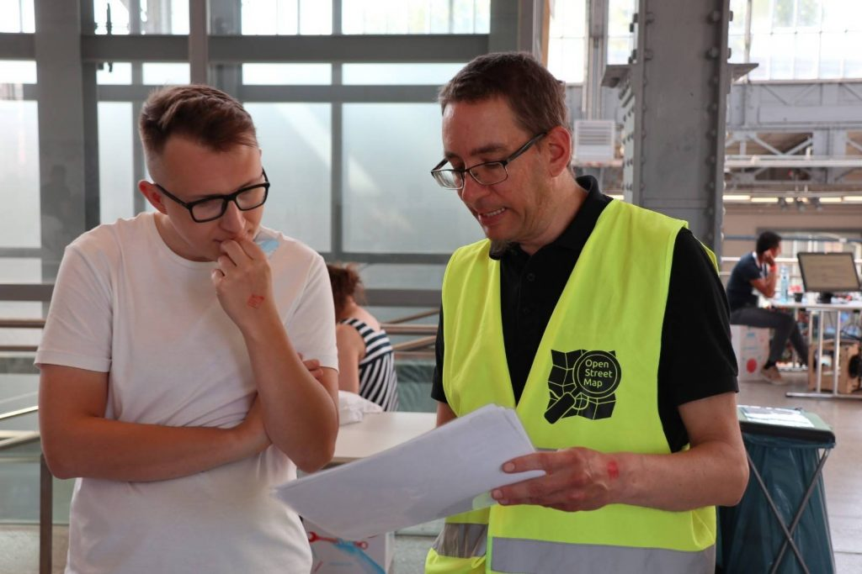
Mapper "skunk" in our great, new safety vest while explaining some OpenStreetMap mapping tools - this safety vest can be purchased directly from us!
We were also asked by the organizers of the Maker Fair Salzburg (AT), Hanover (DE) and Trieste (IT) whether they would like to exhibit the OpenStreetMap there as well. We are already considering Salzburg, we have referred Hanover to the German local chapter (den FOSSGIS eV) and for Trieste we have recommended contacting www.osmit.it .
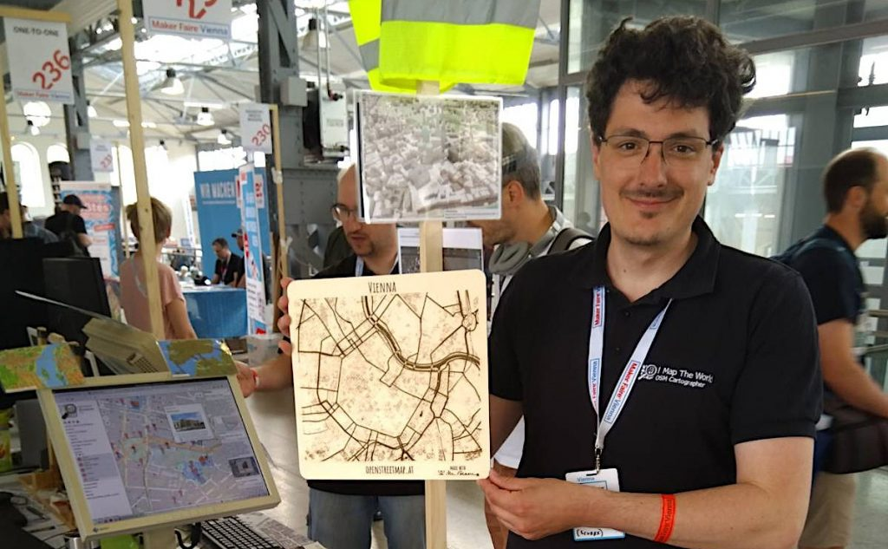
Mapper "ScubbX" with the laser engraving of Vienna's city center, donated by the team behind the laser cutter "Mr Beam" - the OpenStreetMap polo shirt you can see here can now also be obtained from the OSM-AT association again!
From the exhibitors of a laser cutter of the brand "Mr Beam" ( https://www.mr-beam.org ) we received a laser cut of the city center of Vienna on wood!
There was also a short radio interview by mapper "geologist" with a reporter from the radio station Ö1 and a short video interview by mapper "ScubbX" for the Maker Faire press team itself.

